**2. Git Collaboration Class 3**

There will be a group of people working together. Among them there will be one admin and others can be the collaborator.

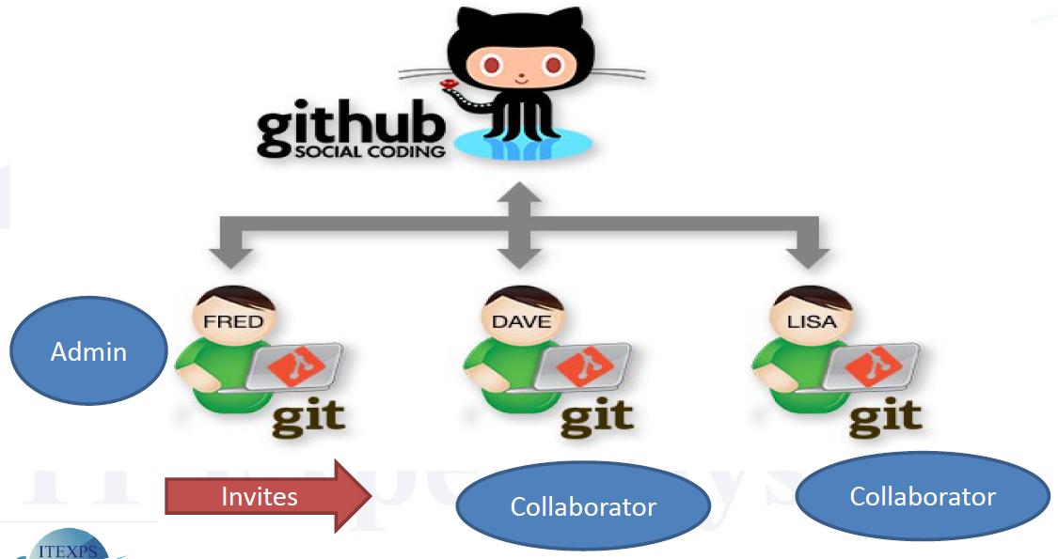

For Admin to follow –

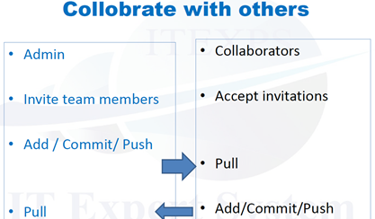

1. Click on the id with the project name you want to work in group, say here it is verma1968 
2. Click on the setting here.

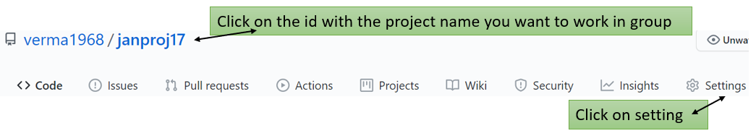

When you click on setting following window will open

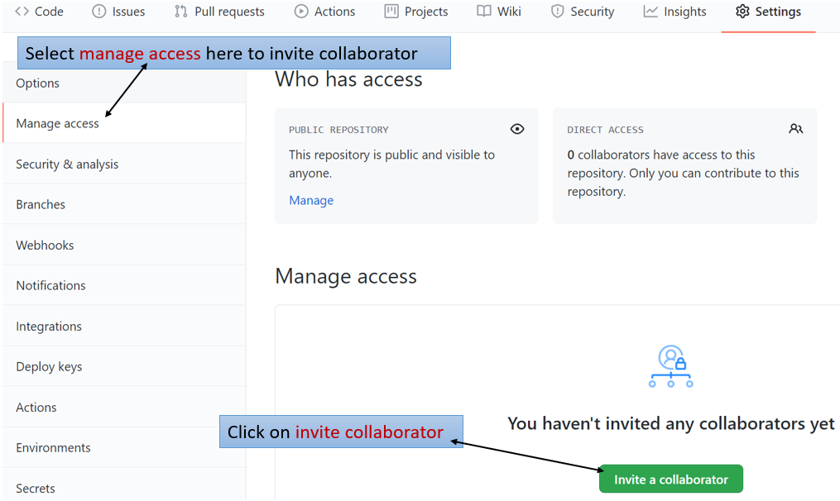

New window will pop.

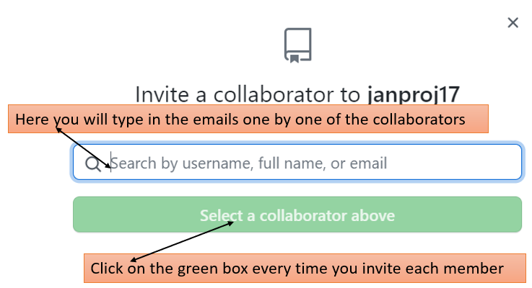

Steps which admin follow on Git Command.

1. Type echo -  with the collaborator’s name. If you have 2 team members or more you will have to type in the same line or press up arrow key and change the name of the collaborator in each line.
2. Type git status - 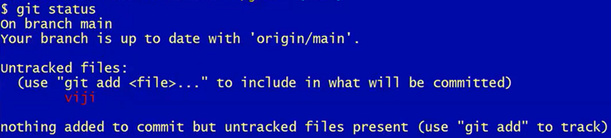
3. Type git add space dot 
4. Type status - 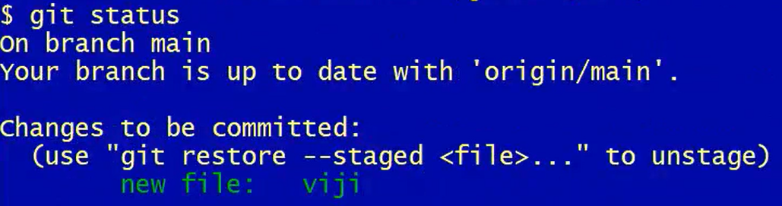
5. Type git commit -m “initial files”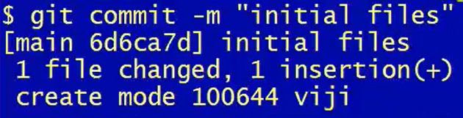
6. Now type git push - 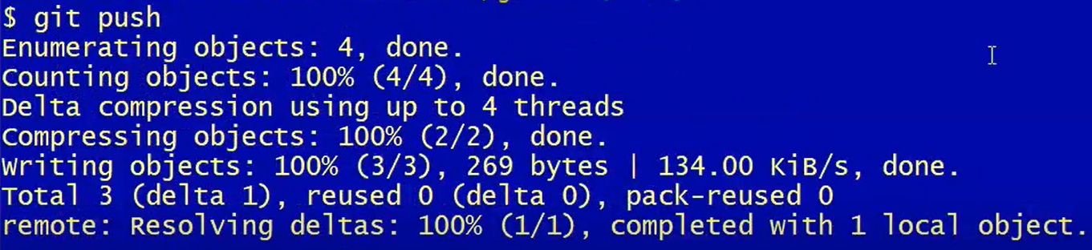

**Steps that collaborator will follow**

When we receive an email from the admin, see it carefully, there will be the repository URL is there. Now open the Git command or bash and follow the following steps: -

After this step we need to write **git** followed by one space, then write **clone** followed by a space finally right clicking and **pasting the URL**  followed by the space type admin name & enter.

Next type cd space admin name & enter.

Next line ls & enter – you will see the collaborator names.

Now admin –

Do Add a new file, echo, commit, and push.

Once admin do the above step, collaborator can now type git space pull. Then type ls to see the file is added.

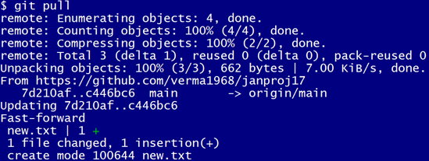

Once collaborators are done working the file, the need to push the file. For this they will type echo

 followed by add file, commit the file and push.

If you push the file **without the admin permission**, you will **get the error**



Now admin needs to pull the file. This is how it works while using git.

In order to come out of the message below

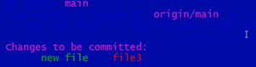

We need to press **escape key** followed by **;q!** press **enter**, once you do this we will get back the dollar sign

To come out of the file you are working with a particular person just type cd space dot dot. After this step if I want to work with other person, I will need to type git clone followed by the URL of that person, press enter. Now write cd space followed by the name of that person and press ender. Now to check whether you are in that persons file type in ls and enter.

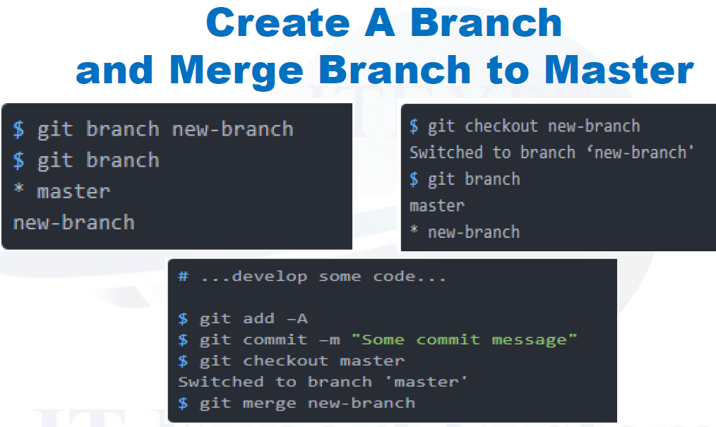

Interview question – they ask about it.

For example, you are working on a product, say amazon shopping cart, it has version 1, which is in production right now (customer is using it). But during this time, we want to add more features on it.

We are working on shopping cart 2. But customer have challenge with the product, so they created defects when they are at version 1. How do we handle this scenario when defects are coming, when we are working with the version 2 with new development? How can we push version 2 now?

Till now we have always worked on the master file. For purposes like above we create branches.

Meaning that we worked with version 1 and have put it in branch 1 as it is now in production. Since we want to add some feature to it, we created version 2 and another branch. These are connected to masters. We can fix the defect here and push it. Also merge it to master. Version 2 can pull it. Always remember that when ever we make the changes in the production branches we merge it to the master and from there to pull it in the current branch to have the update in the branch we are working with.